Money in Motion: The Companion Workbook

Worked Numbers and a Study Guide, Chapter by Chapter
I kept the book itself light on numbers on purpose. The ideas come first, and a page full of columns can bury an idea fast. But some of you want to see the math. You want to trace where a figure comes from, change an assumption, and watch it move. This companion is for you.
Here is how it works. Every chapter gets an entry. Where running real numbers makes the point sharper, you get a worked case study with a table, a chart, and a walkthrough. Where the chapter is more about a concept or a decision, you get a study guide instead: the big idea in a few lines, a couple of questions to consider, and a short list of moves you can make this week.
A few promises about the numbers. Every figure in the insurance case studies comes from a real carrier illustration, the same Penn Mutual whole life and Allianz indexed universal life policies you met in Chapters 6, 7, and 8. I did not invent cash values to make a point. The cases that need an outside assumption, like a rent figure or a market return, say so plainly and label the assumption. And all of it is modeled in a spreadsheet you can open and check, Money in Motion Companion Models. Blue cells are inputs. Change one and the case recalculates.
One thing to note before we start. A policy illustration is not a guarantee. The current-scale columns assume the carrier keeps paying its current dividend or crediting rate. The guaranteed columns are what is promised in the contract. I show both so you can see the floor and the expectation side by side.

Part I: The Banking Problem
Chapter 1
What traditional banking is costing you.

Chapter 1 — The Banking Problem
Run the numbers: what financed living actually costs.
Chapter 1 made the claim that the interest you don’t see is the interest that hurts you. Here is that claim with a price tag. Take an ordinary $300,000 mortgage at 6.5 percent over 30 years. Nothing exotic. Pay it exactly as scheduled and here is what the bank collects.
Milestone | Cumulative interest paid | Principal paid down | Balance left
After Year 1 | $19,401 | $3,353 | $296,647
After Year 10 | $181,873 | $45,672 | $254,328
After Year 20 | $322,085 | $133,004 | $166,996
After Year 30 | $382,633 | $300,000 | $0

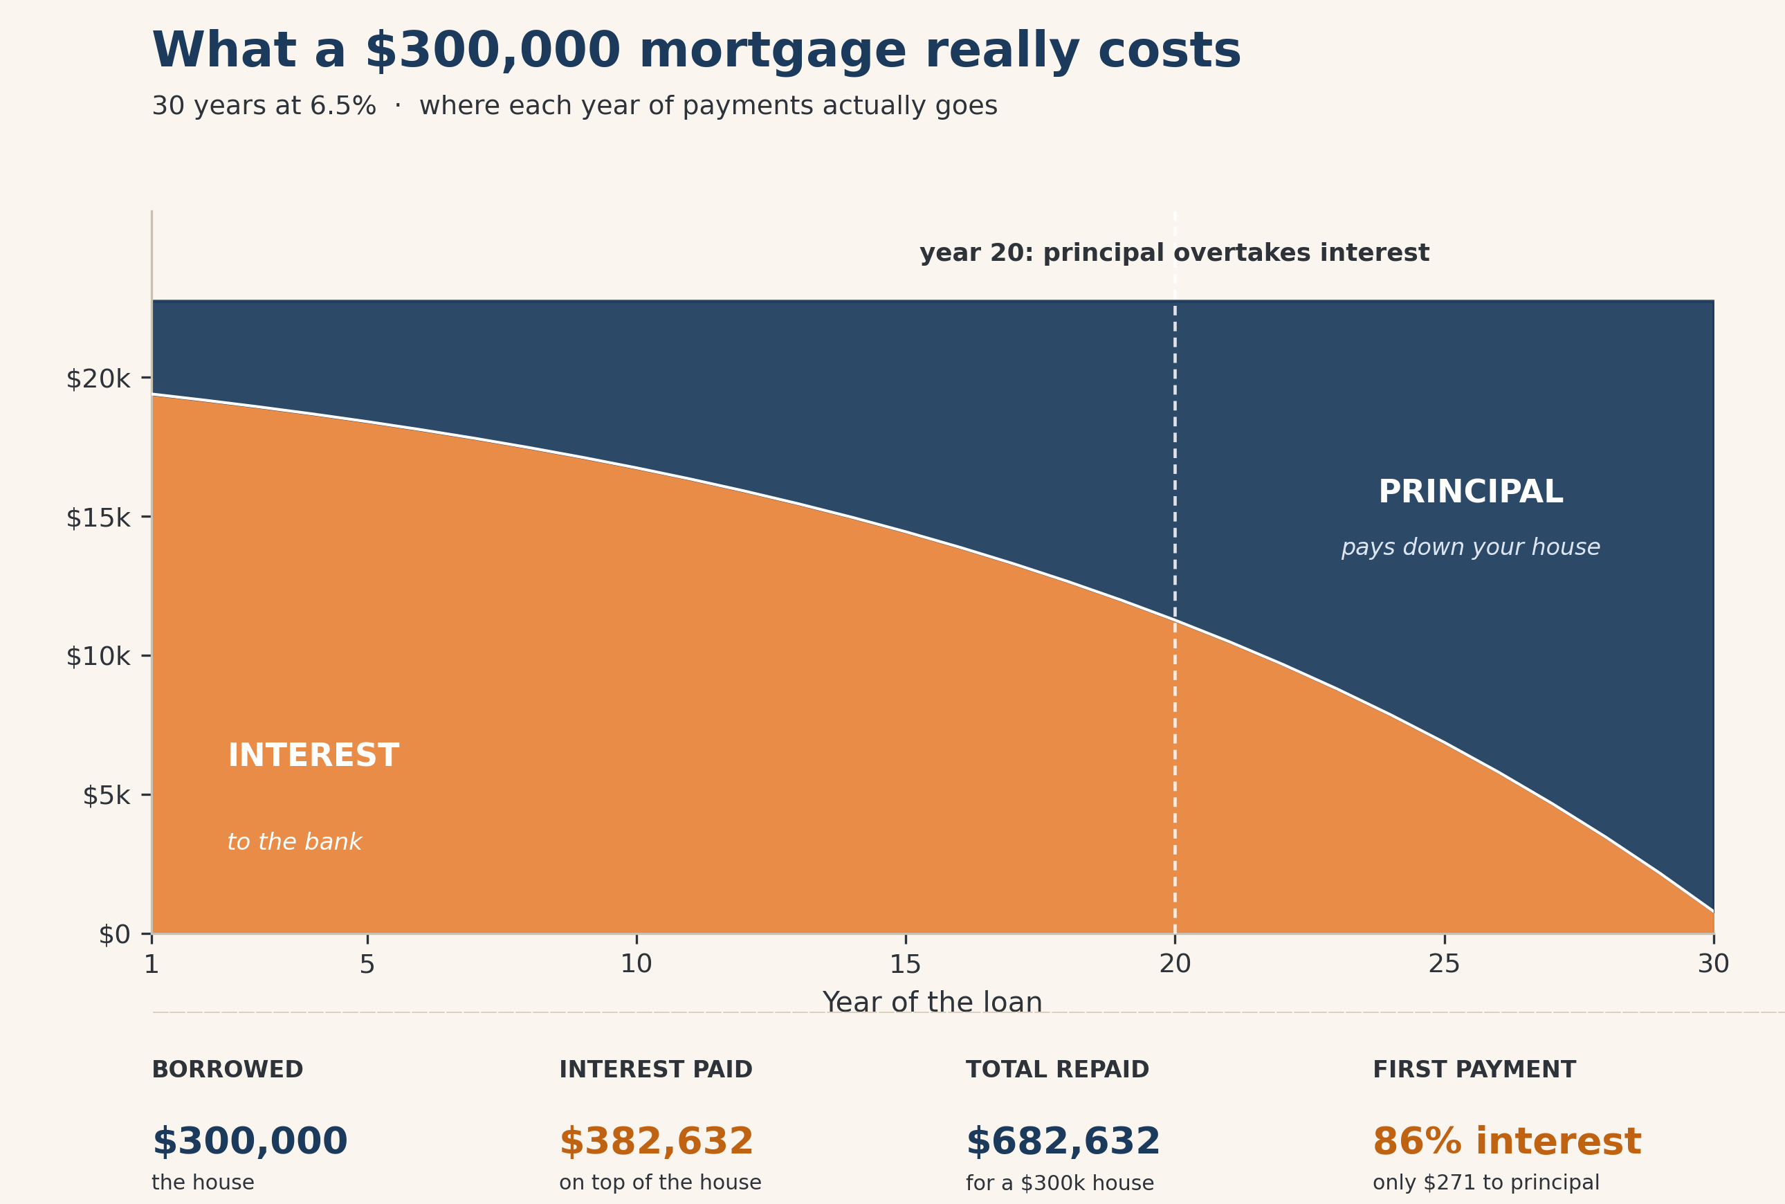
Figure: The first payment is about 86 percent interest. You spend the early years renting the bank’s money.
You borrowed $300,000. You handed back $682,633. The interest alone, $382,633, is more than the house. And look at the first payment: about 86 cents of every dollar goes to interest, not to the home. That is not a scam. That is just how amortization works. The point of the book is not to shame you for having a mortgage. It is to get you to notice that the financing function, the part that collects that $382,633, is a job. Right now a bank holds it. The rest of this book is about taking it back.

Part II: Dynamic Banking
Chapters 2 through 4
The everyday habit that puts your dollars to work while they sit.

Chapter 2 — Dynamic Banking
Study guide.
The big idea. Dynamic banking is not a product. It is a habit, the efficient movement of money. You route income through a line of credit so your dollars knock down expensive balances while they sit there, instead of going idle in a checking account next to debt that is costing you 20 percent. The one mechanical fact to hold onto: when you chunk a balance, you don’t just speed up the payoff, you reprice the whole balance on day one. In the Chapter 3 cases, that repricing alone was worth about $6,500 to one family, on top of everything the discipline earned them.
Questions to consider.
- How much cash is sitting idle in your checking account right now, and what is the highest interest rate you are paying on a balance somewhere else?
- If an emergency hit next month, where would the money come from, and at what rate?
Your move this week.
- Add up every dollar of non-mortgage balance you carry and the rate on each. Just the list. You can’t move money efficiently until you can see it.
- Find out whether you qualify for a HELOC or a personal line of credit, and at what rate. You are not committing to anything. You are pricing the tool.

Chapter 3 — Case Studies in Dynamic Banking
Run the numbers: four households, one playbook.
This is the strongest section of the first half, and for good reason. Same dollars, three different routes, real interest math. Here are all four households side by side, the interest each paid over 24 months under three approaches: paying minimums only, throwing every spare dollar straight at the debt, and dynamic banking.
Household | Minimums only | Every spare dollar | Dynamic Banking | Kept reachable
Dave & Emily | $10,400 | $8,300 | $1,800 | $23,000
Raj & Priya | $10,900 | $5,400 | $2,800 | $50,000
Marcus | $7,700 | $3,500 | $2,000 | line stayed open
Nicole | $6,200 | $4,800 | $3,000 | line stayed open

Look at the middle column first, because that is the disciplined family working hard. They threw every spare dollar at the debt and still paid real interest, because every dollar they hadn’t paid off yet kept costing full rate the whole way down. Dynamic banking beat even that disciplined path, by about $12,000 across the four households combined. And the last column is the part the interest table can’t show. The disciplined family’s money is gone, locked inside paid-off balances. The dynamic banking family killed the same debt and kept the money reachable the entire time. Same dollar, two jobs.
Your move this week.
- Pick the one household above that looks most like yours. Open the Companion Models spreadsheet, find the matching tab, and change the income and balances to your own. Watch your number move.
- Write down your own version of the bottom row: if you sent every spare dollar at your debt, how many days could you go before you’d have to swipe a card again?

Chapter 4 — A Month Inside Dynamic Banking
Run the numbers: the rhythm of one month.
Chapter 4 walked through a single month so the strategy stops feeling abstract. The mechanics are simple once you see them move. Income lands on the line the day it clears, which drops the balance and the interest that day. Living expenses come off the line through the month. Because interest is charged on the average daily balance, parking income early and spending late shrinks the number the bank multiplies against.
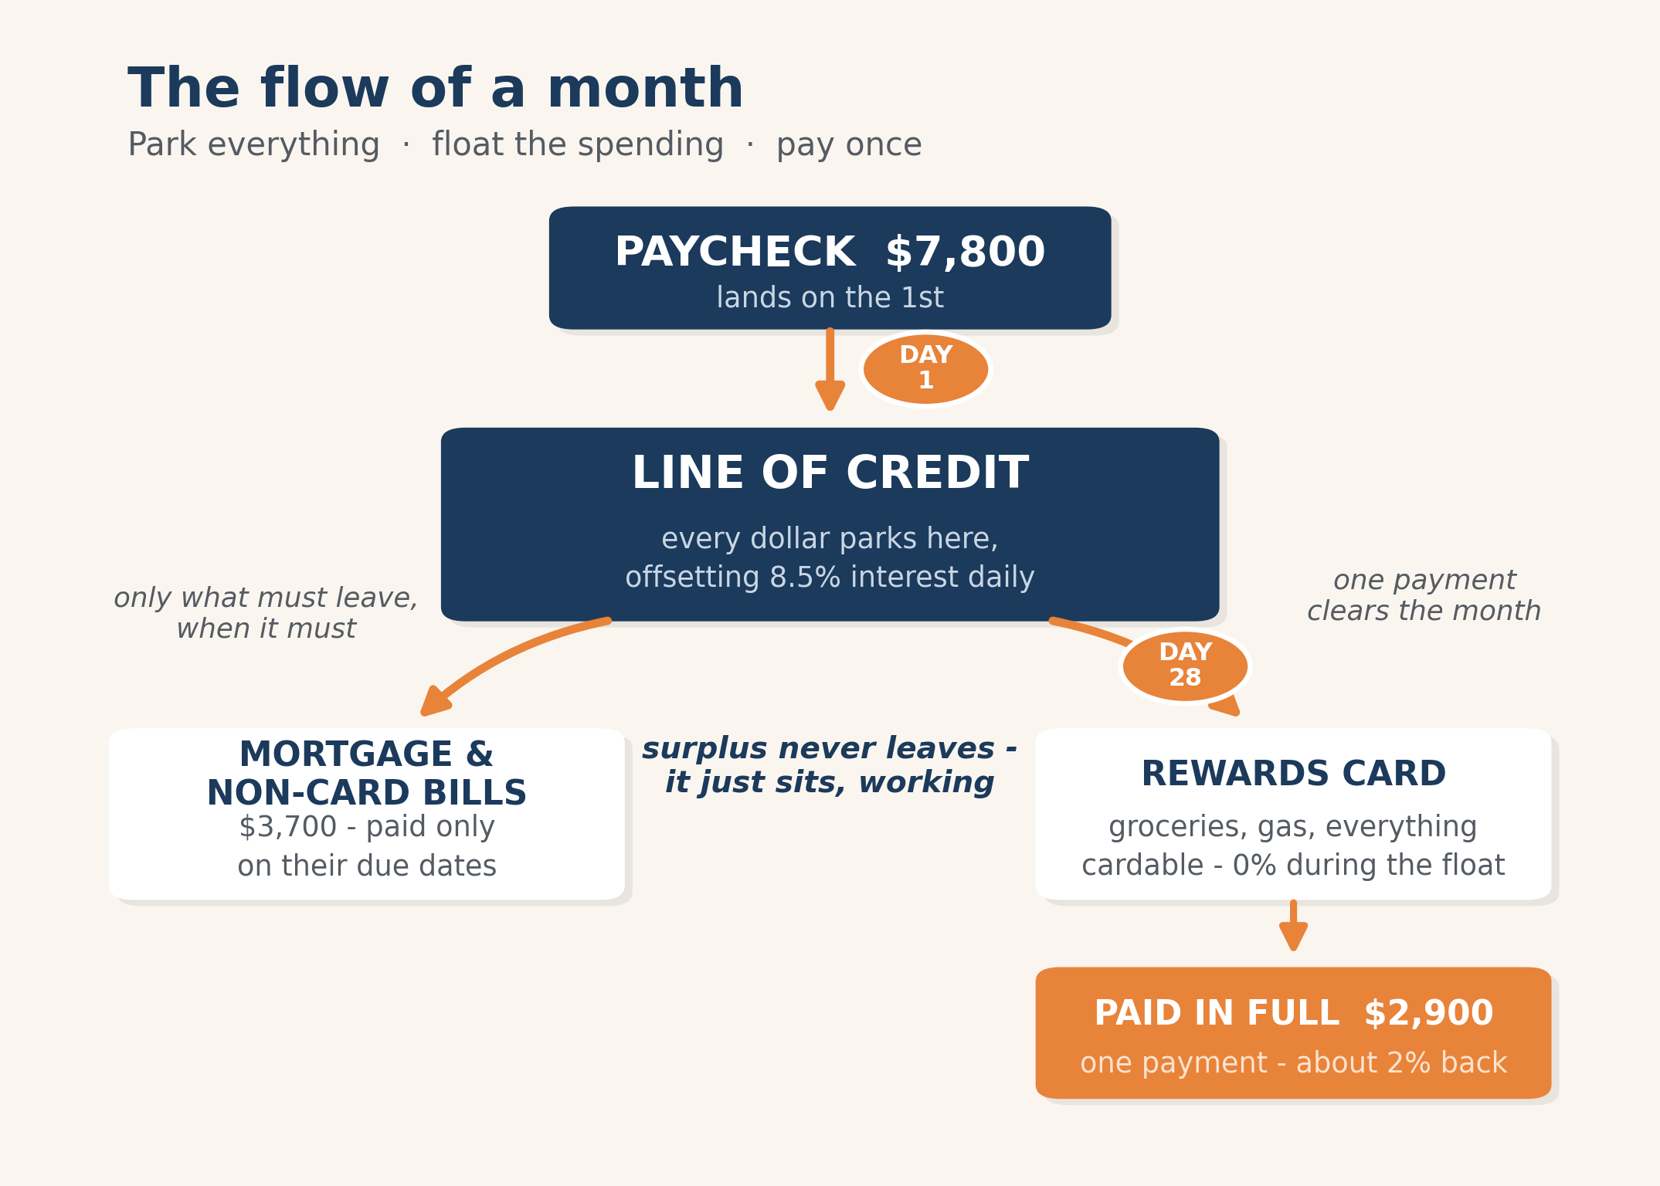
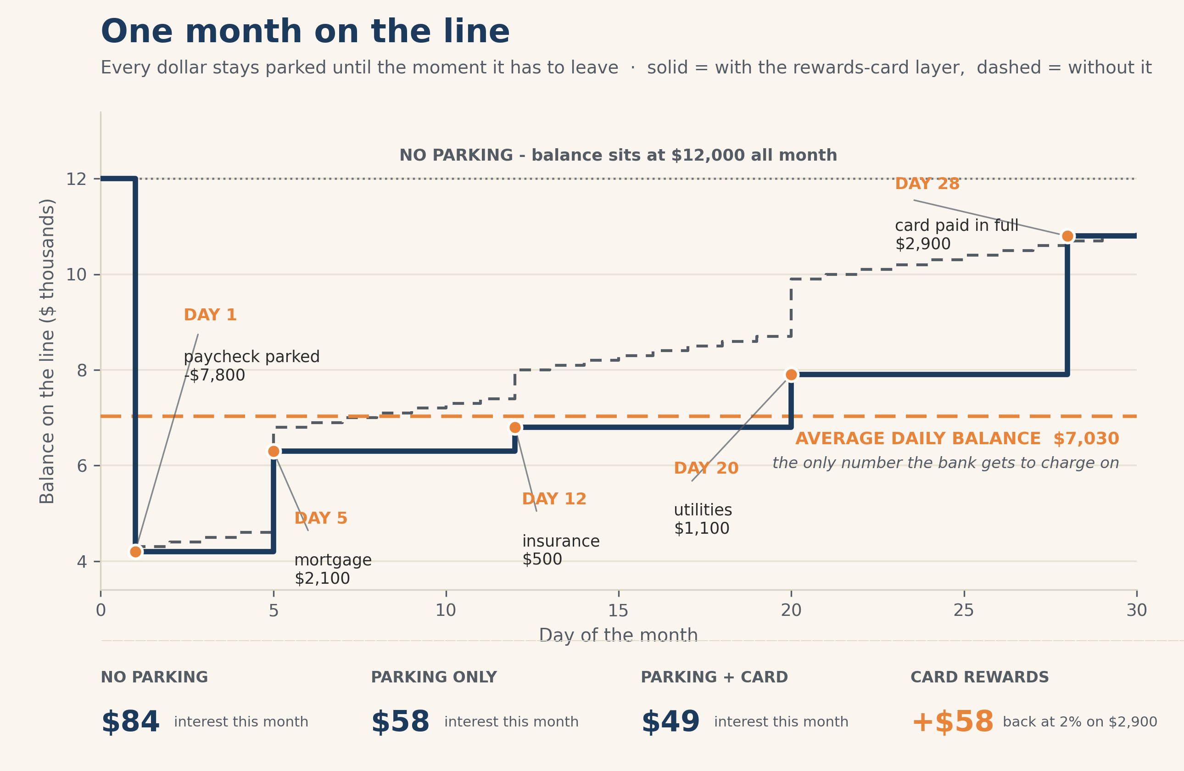
Figure: Park early, spend late. The average daily balance is what gets charged, so the shape of the month matters as much as the totals.
That is the whole trick. You are not spending less. You are moving the same dollars in a smarter order, and the average daily balance does the rest. A few dollars a month sounds like nothing. It compounds into real money, and more importantly it builds the habit that everything in the back half of this book runs on.

Part III: A Lifetime Line of Credit
Chapters 5 through 8
The asset behind it all, and why the design matters more than the product.

Chapter 5 — Building a Line of Credit That’s Guaranteed for Life
Study guide.
The big idea. There are really only two flavors, term and permanent, and most of the confusion is marketing on top of that. Term is cheap protection for a set window. Permanent is protection that doesn’t expire and builds cash value you can use while you’re alive. The book’s caution about “buy term and invest the difference” isn’t that it’s wrong on paper. It’s that it asks you to do the hard part, invest the difference every single month for decades, and most people never do.
Do the coverage math once. A simple way to size a death benefit: add up what you’d want to replace. Debts, income for the years your family would need it, the mortgage, and anything specific like college. Total it, subtract what’s already covered, and that’s your number. Do it once and stop guessing.
Questions to consider.
- If your income stopped tomorrow, how many years would your family need it replaced, and have you ever actually multiplied that out?
- Do you own protection that expires, protection that builds, or both, and is that on purpose?
Your move this week.
- Run the coverage math above. One number.
- If all you own is term, that’s fine, it’s doing a job. Ask whether some permanent coverage alongside it would let that same premium build something you can use before you die.

Chapter 6 — Whole Life Insurance: The Engine
Run the numbers: twenty years inside a well-designed policy.
This is the real one. A 40-year-old man in good health, a Penn Mutual policy designed for cash value, $24,810 a year. These are the actual illustration figures, both the guaranteed floor and the current-scale expectation.
Year | Premiums Paid | Guaranteed Cash Value | Current-Scale Cash Value | Death Benefit (Current)
1 | $24,810 | $20,058 | $20,567 | $557,780
5 | $124,051 | $113,579 | $125,739 | $800,593
10 | $248,101 | $248,250 | $299,901 | $1,114,827
15 | $372,152 | $400,386 | $533,876 | $1,457,177
20 | $496,202 | $567,434 | $839,760 | $1,832,717

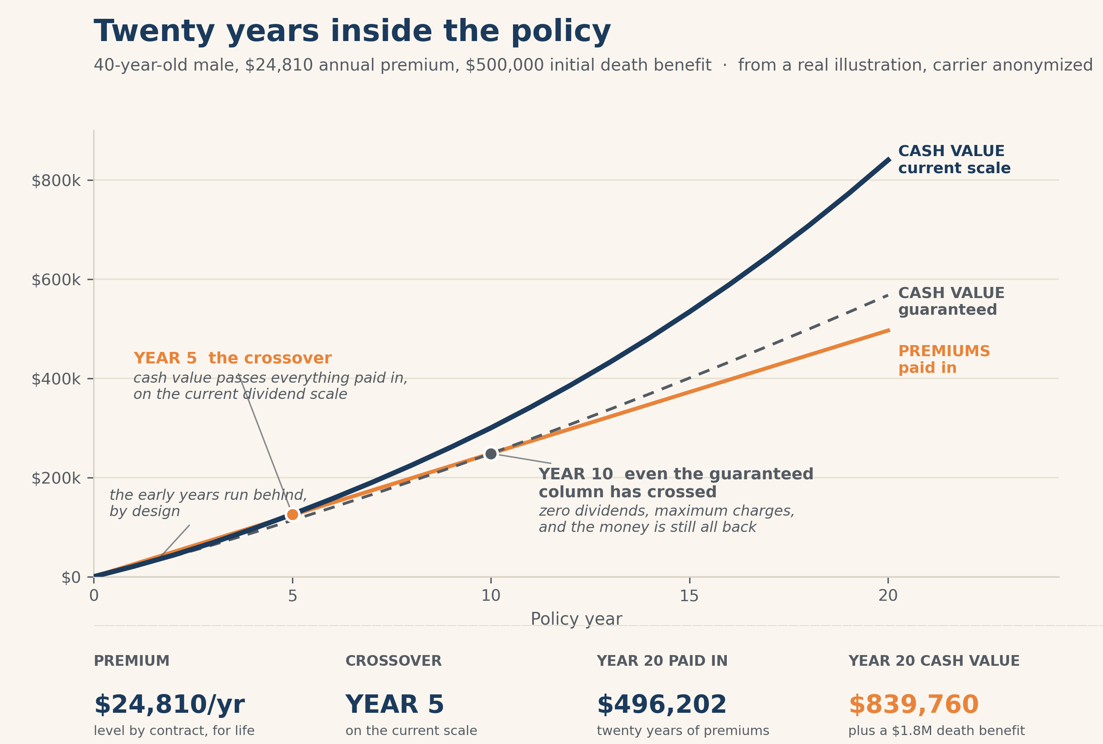
Figure: On the current scale, cash value passes total premiums paid by Year 5. Even the guaranteed column passes by Year 10.
Read the guaranteed column first. That is the promise, the part that doesn’t depend on the company having a good decade. Even that promised column passes your total premiums by Year 10. On the current scale, where the carrier keeps paying the dividend it pays today, you’re ahead by Year 5. By Year 20 the cash value is $839,760 against $496,202 paid in, and the death benefit has grown to over $1.8 million from a starting half million. That growth, year after year, with the lid never coming off, is the engine the rest of the book plugs into.

Chapter 7 — Indexed Universal Life: The Alternative
Run the numbers: the same machine, different settings.
Whole life is the engine. Indexed universal life is the same idea wired to the market’s upside with a floor under it. This is a real Allianz illustration on an 18-year-old woman, $11,320.98 a year, illustrated at 6 percent.
Year | Premiums Paid | Guaranteed Cash Value | Current-Scenario Cash Value | Death Benefit (Current)
1 | $11,321 | $7,049 | $7,738 | $410,555
5 | $56,605 | $46,789 | $57,746 | $460,396
10 | $113,210 | $97,702 | $143,196 | $544,479
15 | $169,815 | $148,579 | $263,196 | $663,196
20 | $226,420 | $197,856 | $429,083 | $1,072,707

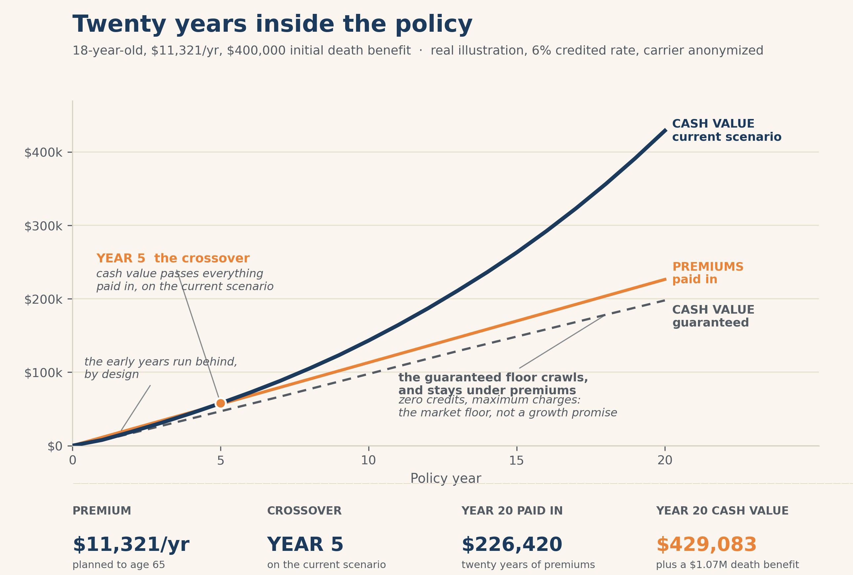
Figure: The floor protects against market loss. It does not promise growth. Growth is the current-scale expectation.
Now look at the guaranteed column and notice something the slick presentations breeze past: it stays under premiums for a long time. That is honest. The floor’s job is to protect you from a market drop, not to promise you a return. The growth lives in the current-scenario column. Give that same policy a long runway and the time does the work. On the current scale this policy reaches roughly $3.25 million in cash value by age 65, with a death benefit near $3.97 million, and around $4.5 million in cash value by age 70. Starting young and funding it well is most of the story.

Chapter 8 — Policy Design: Why Most Policies Fail
Run the numbers: the same product, designed two ways.
This is the chapter that makes everything else possible, so it gets two tables. Same insured, same carrier, same premium each time. The only thing that changes is the design. First, the whole life policy at $24,810 a year, the off-the-shelf version a random agent hands you versus one built for cash value.
Year | Premiums Paid | Cash Value, Off-the-Shelf | Cash Value, Well-Designed
1 | $24,810 | $0 | $20,567
5 | $124,050 | $71,446 | $125,739
10 | $248,100 | $240,291 | $299,901
15 | $372,150 | $464,068 | $533,876
20 | $496,200 | $743,025 | $839,760

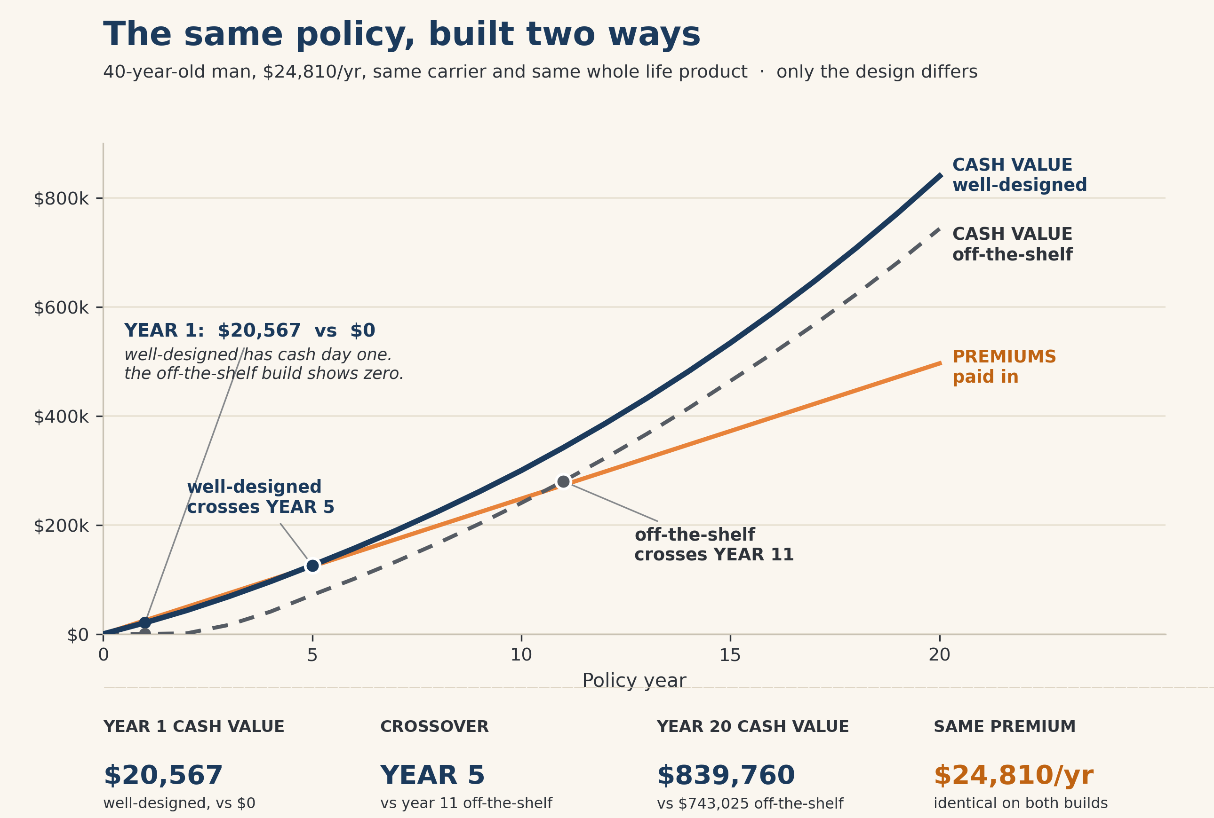
The off-the-shelf design gives you zero cash value in year one and doesn’t cross your premiums until around Year 11. The well-designed one hands you $20,567 in year one and crosses by Year 5. Same money. The off-the-shelf version bought a $1.5 million death benefit you may not need and starved the cash value you came for. Now the same trap in an IUL, poor design versus well-designed.
Year | Premiums Paid | Cash Value, Poor Design | Cash Value, Well-Designed
1 | $11,321 | $0 | $7,738
5 | $56,605 | $19,081 | $57,746
10 | $113,210 | $111,241 | $143,196
15 | $169,815 | $232,731 | $263,196
20 | $226,420 | $390,310 | $429,083

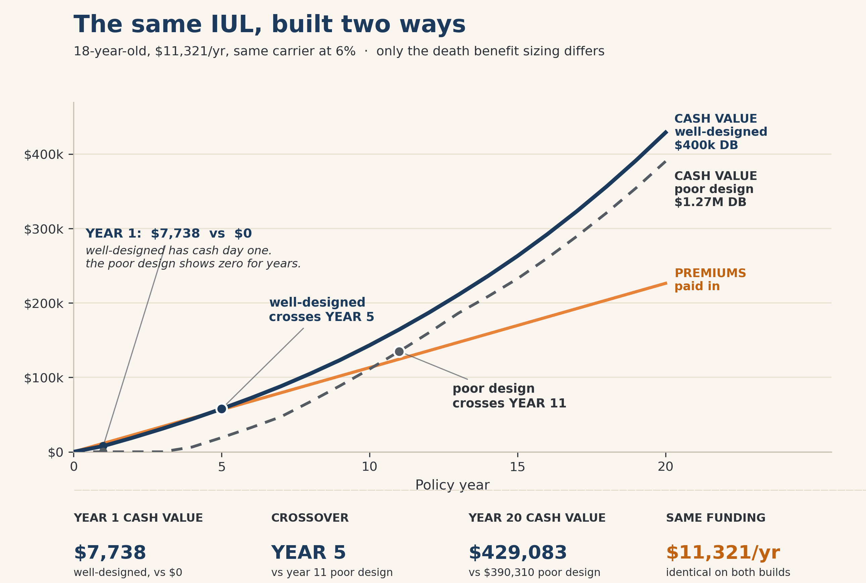
Figure: Both designs converge late. A slick agent will point at the far-right number and tell you design barely matters. But you live in the early years.
Here is the sneaky part. By the time these policies reach old age, the two designs nearly converge. So an agent can show you the far-right number and claim the design hardly matters. But you don’t live at the far right of the table. You live in the early years, where the gap is enormous, where the cash value you can actually borrow against is the difference between zero and real money. The far-right number is not the point. The shape is.

Part IV: Your Personal Banking System
Chapter 9
Putting the engine to work as your own source of financing.

Chapter 9 — Your Personal Banking System
Study guide.
The big idea. Once the engine is built, you bank through it. Not your groceries, the carrier is not a checking account. The big financing events. The car, the equipment, the down payment, the emergency fund. You borrow against the policy or against an outside line collateralized by it, and here is the part that does the work: borrowing against your cash value does not remove it. The full balance keeps compounding as if you never touched it.
See it with one small example. Say you’ve got $40,000 of cash value and you need $10,000 for a used car. You borrow the $10,000 against the policy. The car gets paid for. And the entire $40,000 keeps earning dividends, because the carrier lent you their money against your value as collateral, they didn’t withdraw your value. The dollar you spent on the car is also still the dollar earning inside the policy. That is the whole concept, and it scales from a used car to a rental property.
Questions to consider.
- What is the next big thing you’ll need to finance, and who is going to collect the interest on it?
- Are you comfortable being your own honest banker, meaning you actually pay the loan back on a schedule, the way a bank would make you?
Your move this week.
- List the next three financing events you can see coming in the next few years. Those are the jobs your banking system is for.
- Decide now what “paying yourself back” will look like, a real monthly number, so the system stays funded.

Part V: Strategic Applications
Chapters 10 through 12
Where you point the system: real estate, your business, and the income years.

Chapter 10 — Real Estate and Investment Capital
Run the numbers: a rental, bought with your own bank.
This is the case readers ask about most, using the policy to buy a rental. Let’s run it in full. Take Jones, who has a whole life policy with about $80,000 of cash value, roughly Year 4 of the Chapter 6 policy. He wants a rental. He borrows $50,000 against the policy at 5 percent and buys a modest property for cash. The rent and costs below are realistic assumptions, labeled as such in the spreadsheet.
The rental, year one | Amount
Gross rent ($1,200/mo) | $14,400
Operating costs ($360/mo) | -$4,320
Net operating income | $10,080
Loan repayment ($50,000 at 5% over 10 yrs) | -$6,475
Net cash flow, after the loan | +$3,605
Depreciation (a non-cash tax deduction) | -$1,818
Taxable rental income after depreciation | $5,762

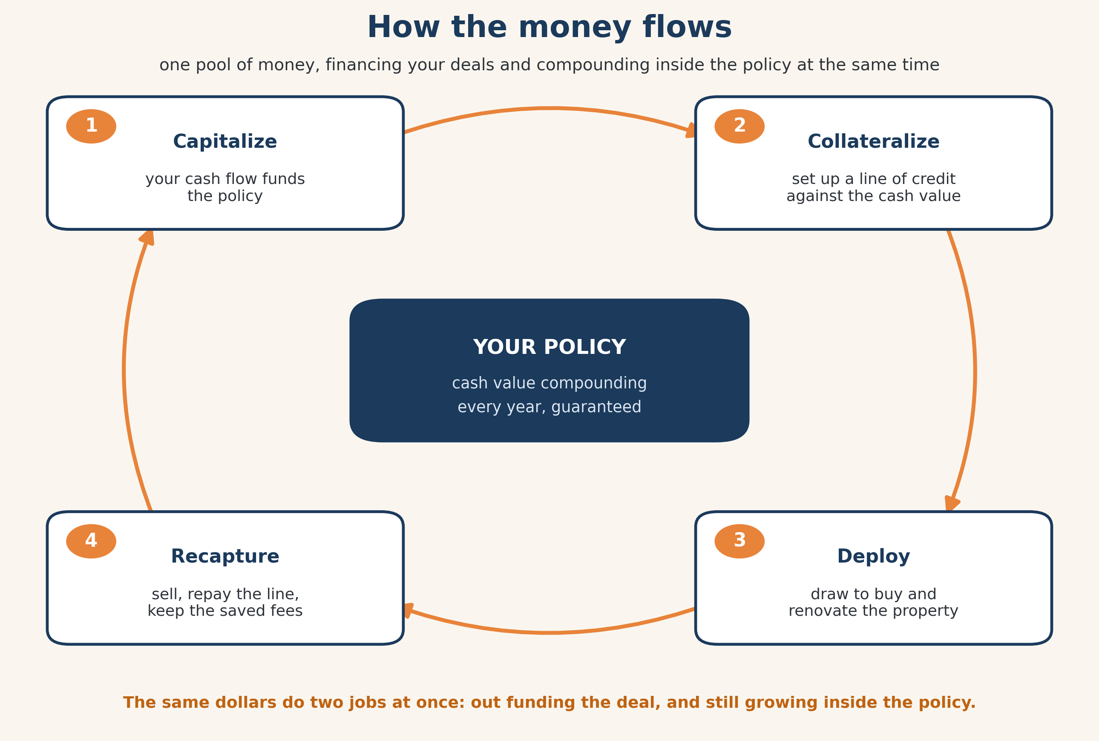
Figure: Capitalize, collateralize, deploy, recapture. The cash value keeps compounding the whole way around the loop.
Positive cash flow from day one, $3,605 in the first year, and it climbs as the loan gets paid down. After ten years the loan is gone and Jones owns the rental free and clear. That’s Job One. Now Job Two. The $50,000 he borrowed never left the policy. A loan is collateralized, not withdrawn, so the full $80,000 of cash value keeps earning dividends as if the rental purchase never happened. Over that same decade, a policy near $80,000 keeps compounding toward six figures on its own. Compare that to paying $50,000 cash for the rental. Cash would have done Job One only. The dollar leaves, and it stops compounding. Same purchase, half the working power. That is the arbitrage, realistically: you are not promised a fixed spread, but the same dollar really is doing two jobs at once.

Chapter 11 — Retirement Income Planning
Run the numbers: the buffer that changes the math.
The danger in retirement isn’t a bad year. It’s a bad year early, while you’re also drawing income, because selling into a drop locks the loss in. Here are two retirees, identical in every way. Same $1 million, same $50,000 a year of income, the same exact market: down 30, down 10, then up 20, up 15, up 10, and a steady 8 percent after that. The only difference is that one sells from the portfolio every year, and the other covers the two down years from cash value instead.
 | Retiree A: sells every year | Retiree B: buffers the down years
Starting portfolio | $1,000,000 | $1,000,000
After the down years and recovery | drew down at the bottom | left it alone to recover
Portfolio after 15 years | $612,527 | $863,237

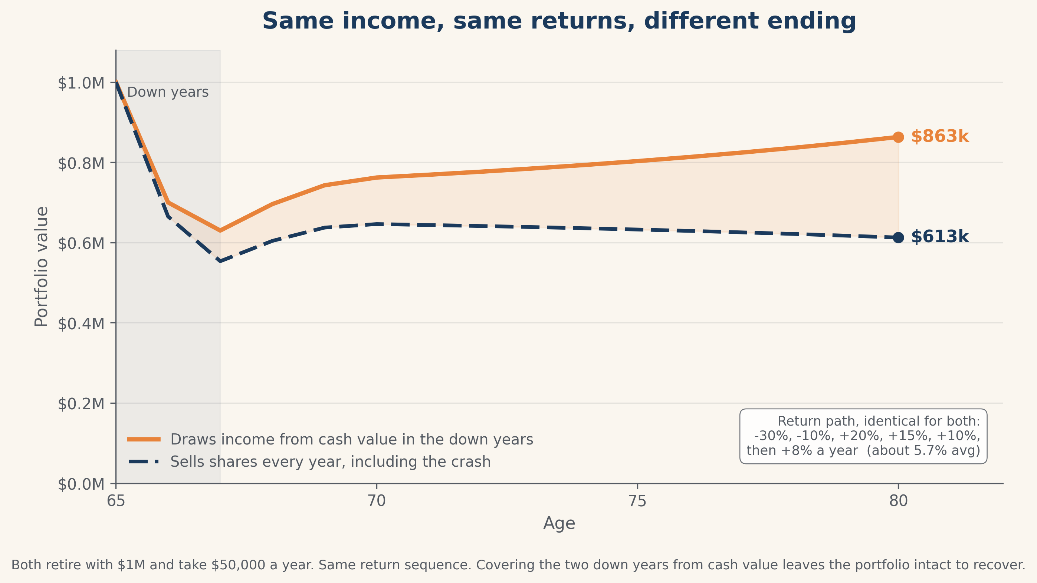
Figure: Same money, same income, same market. The gap, about $251,000, comes entirely from not selling at the bottom.
That gap, $250,709, is not from a better return. Both retirees lived through the identical market. It’s from what they sold and when. Retiree B had a separate pool, the policy’s cash value, to draw from during the two down years, so the portfolio was never sold at the bottom. That is what the floor under an IUL is really for in retirement.
And the income itself can be tax-free. Take the Chapter 7 policy at age 65, around $3.25 million of cash value. A conservative 4.5 percent draw is about $146,250 a year, accessed through policy loans and withdrawals to basis, which is not reported as taxable income. Don’t get hung up on what an illustration can show for income, the numbers can be manipulated, and real cash growth is what drives a real draw. But the structure is the point: a pool you can pull from in down years, and pull from without a tax bill.

Chapter 12 — Business Owners and Key Person Strategies
Run the numbers: a business as its own bank.
Most businesses keep money sloshing around doing nothing. The payroll float, the tax set-aside, the fund for the next piece of equipment. It goes up and down and earns nothing. Here’s that same money put to work. The owner redirects it into a well-designed policy, the same $24,810-a-year whole life from Chapter 6, then borrows against the policy when the business needs capital.
Year | Premium into policy | Policy cash value | Borrowed for the business | Still compounding?
1 | $24,810 | $20,567 | — | Yes, untouched
2 | $24,810 | ~$57,000 | $30,000 for equipment | Yes, the loan is collateralized
3 | $24,810 | ~$96,000 | repaying | Yes
4 | $24,810 | ~$110,000 | repaid | Yes, full value plus the equipment
5 | $24,810 | $125,739 | — | Yes

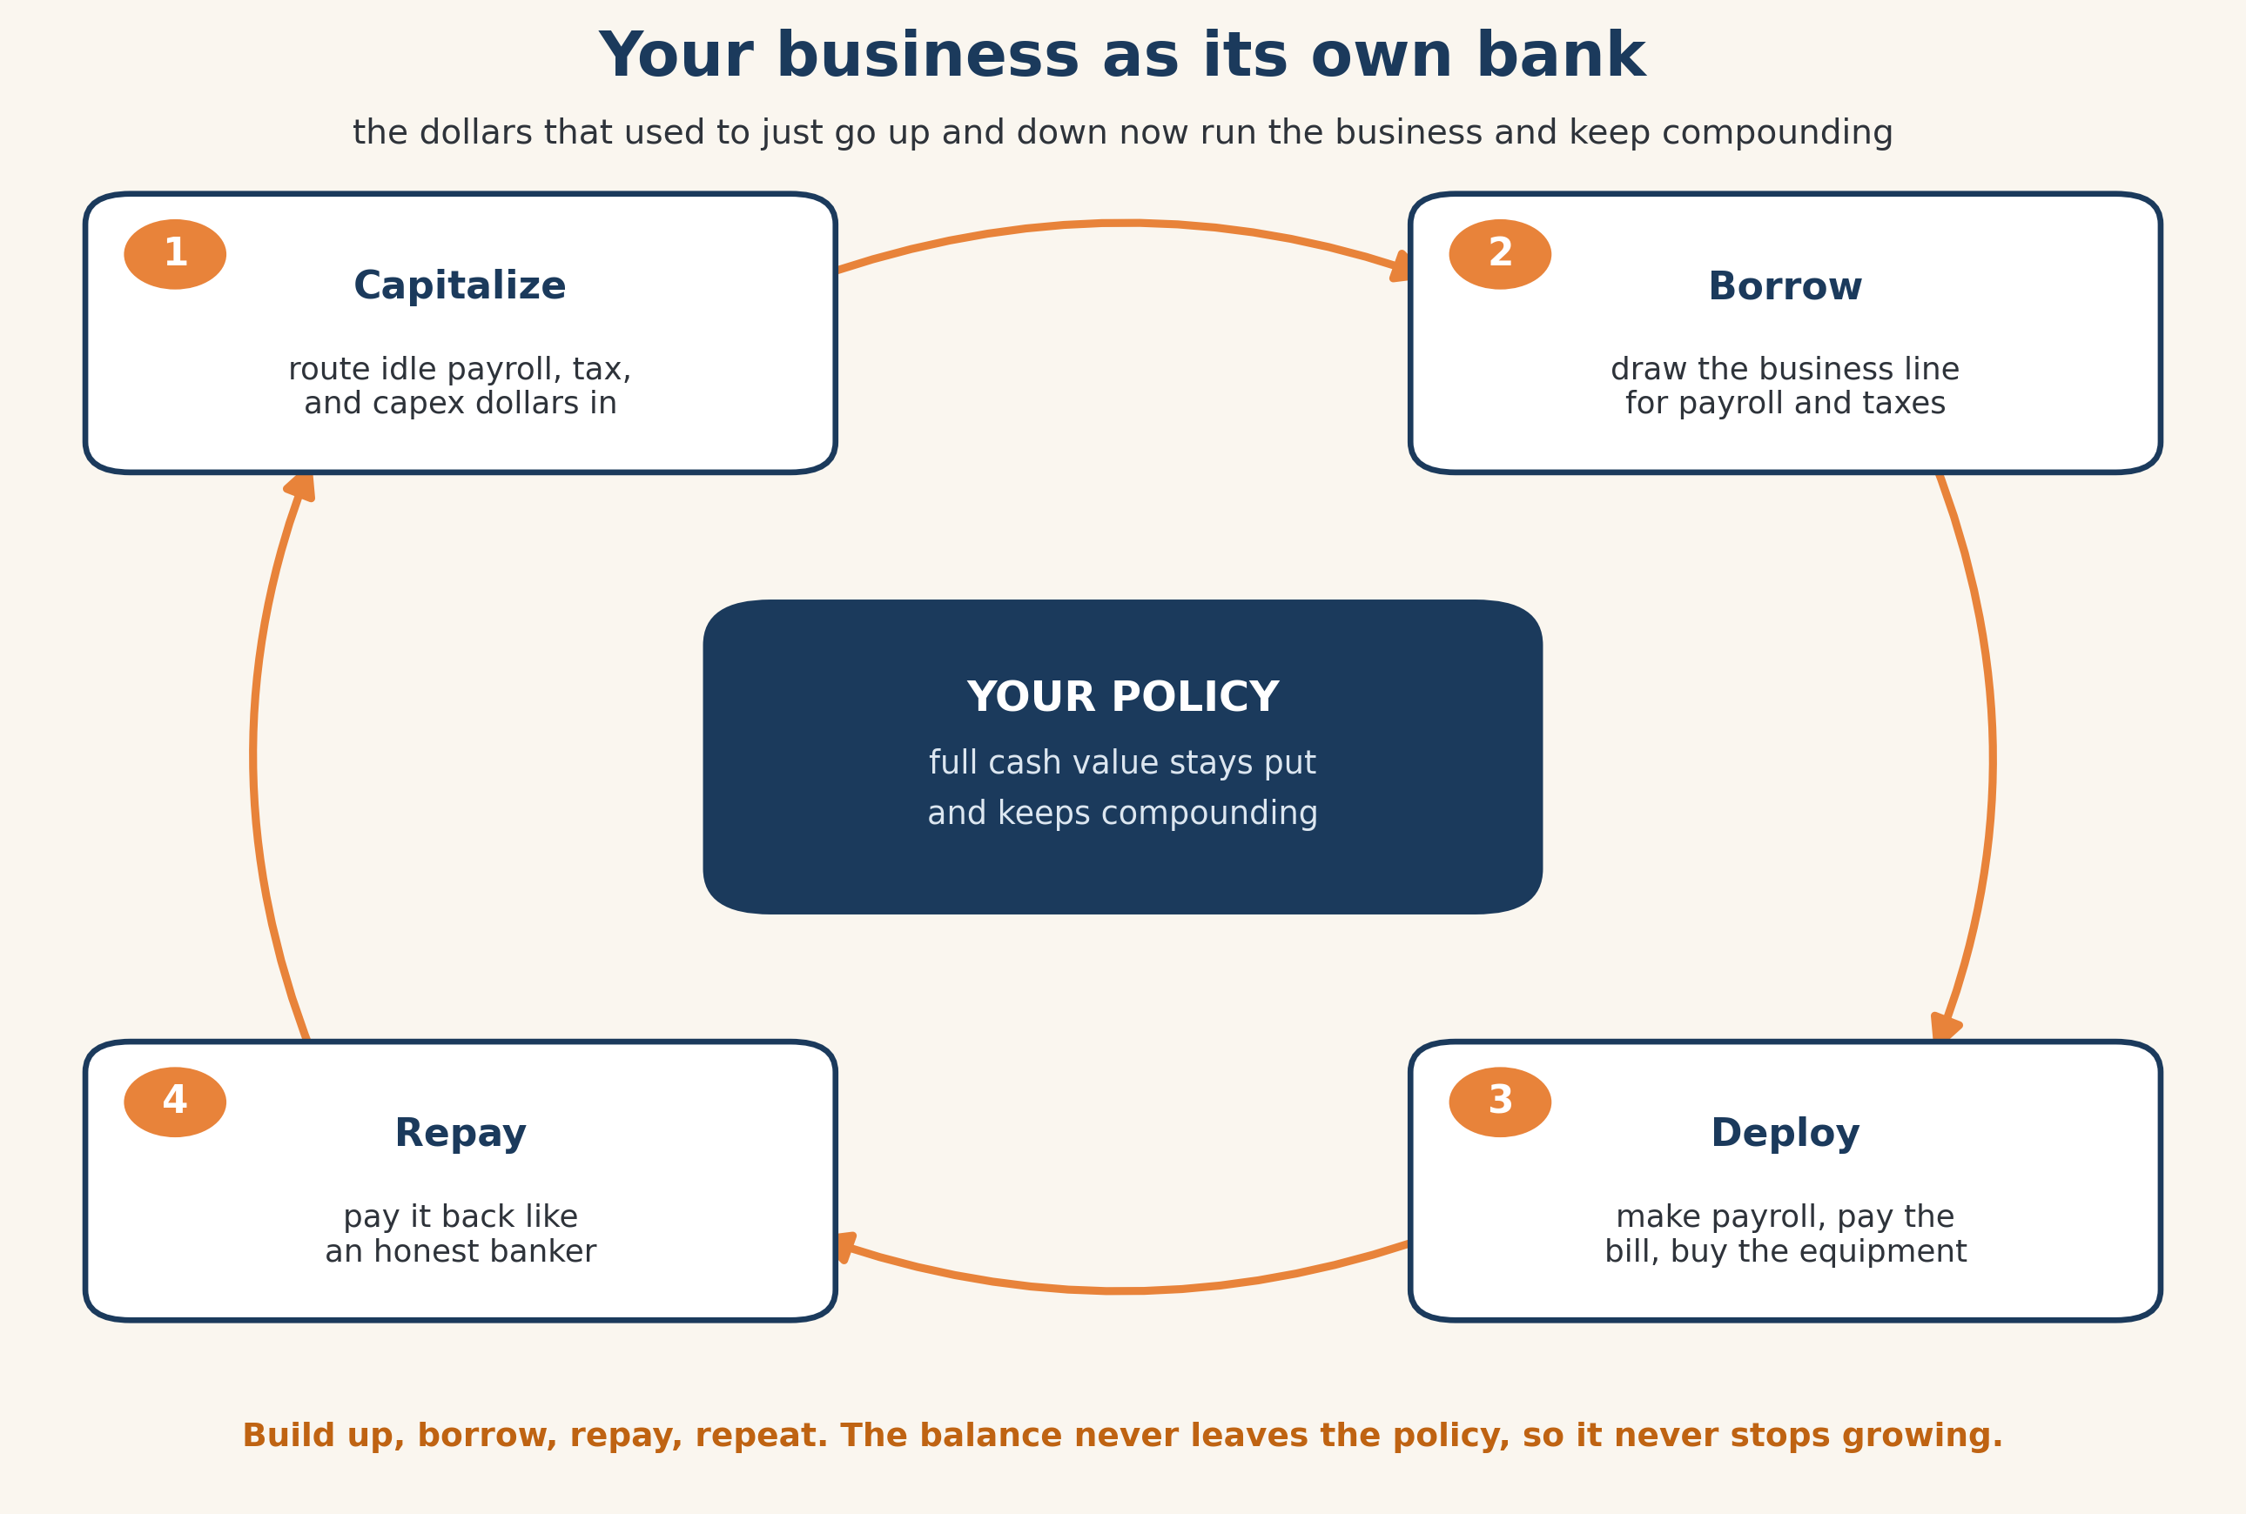
Figure: Capitalize, borrow, deploy, repay. The full cash value stays put and keeps compounding through the whole cycle.
In Year 2 the business borrows $30,000 against the policy to buy a piece of equipment and repays it over the next two years from operations. The cost to borrow is modest, a few thousand dollars of interest, and when the line is used only for the business, that interest is generally deductible. Check with your CPA on your situation. But here’s the move: while the business borrowed, deployed, and repaid, the cash value never stopped growing, climbing to $125,739 by Year 5. The reserve dollars did two jobs. They built a growing asset, and they bought the equipment. It’s the bank you own instead of the one you rent.

Part VI: Tax and Legacy
Chapters 13 through 14
Keeping what you built.

Chapter 13 — Tax Strategy and the Tax-Free Bucket
Run the numbers: same dollars, three tax treatments.
Most people have all their money in one tax bucket and don’t realize it. Here are three, fed the same way: $10,000 a year for 20 years, at the same assumed 7 percent growth so that the only thing that differs is how the tax code treats each one. The growth rate is an assumption, labeled in the spreadsheet. The lesson isn’t the dollar amount, it’s the gap that opens from tax treatment alone.
Bucket | Going in | While it grows | Coming out | Ending value, after tax
Taxable brokerage | After-tax | Taxed yearly | Gains taxed | $352,423
Tax-deferred (Traditional) | Pre-tax | Tax-deferred | Taxed as income | $311,566
Tax-free (Roth or policy) | After-tax | Tax-free | Tax-free | $409,955

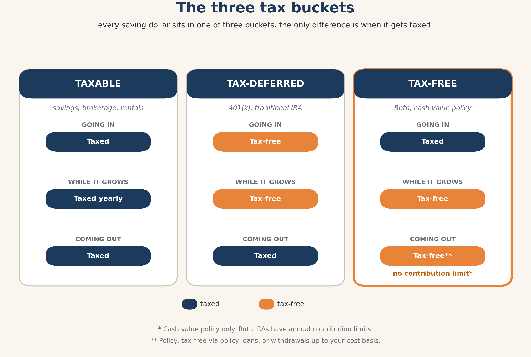
Figure: The tax-free bucket keeps what the others hand back. The cash value policy has no IRS contribution limit, where a Roth does.
Same contributions, same growth, and the tax-free bucket ends nearly $100,000 ahead of the tax-deferred one, because the deferred bucket gives a chunk back on the way out. The properly designed policy lives in that third column, accessed tax-free through loans or withdrawals to basis, and unlike a Roth it has no contribution limit. Tax law can change, and this isn’t your CPA, so confirm the specifics. But the structure is the advantage: you keep what the other buckets give back.

Chapter 14 — Generational Wealth and Legacy
Run the numbers: a policy that starts a family bank.
The cleanest way to move money to the next generation is a death benefit, and it gets cleaner when you start early. The Chapter 7 policy is on an 18-year-old. Look at what time does to it on the current scale.
Age | Cash value (current scale) | Death benefit (current scale)
23 (Year 5) | $57,746 | $460,396
28 (Year 10) | $143,196 | $544,479
38 (Year 20) | $429,083 | $663,196
65 | ~$3,250,000 | ~$3,970,000

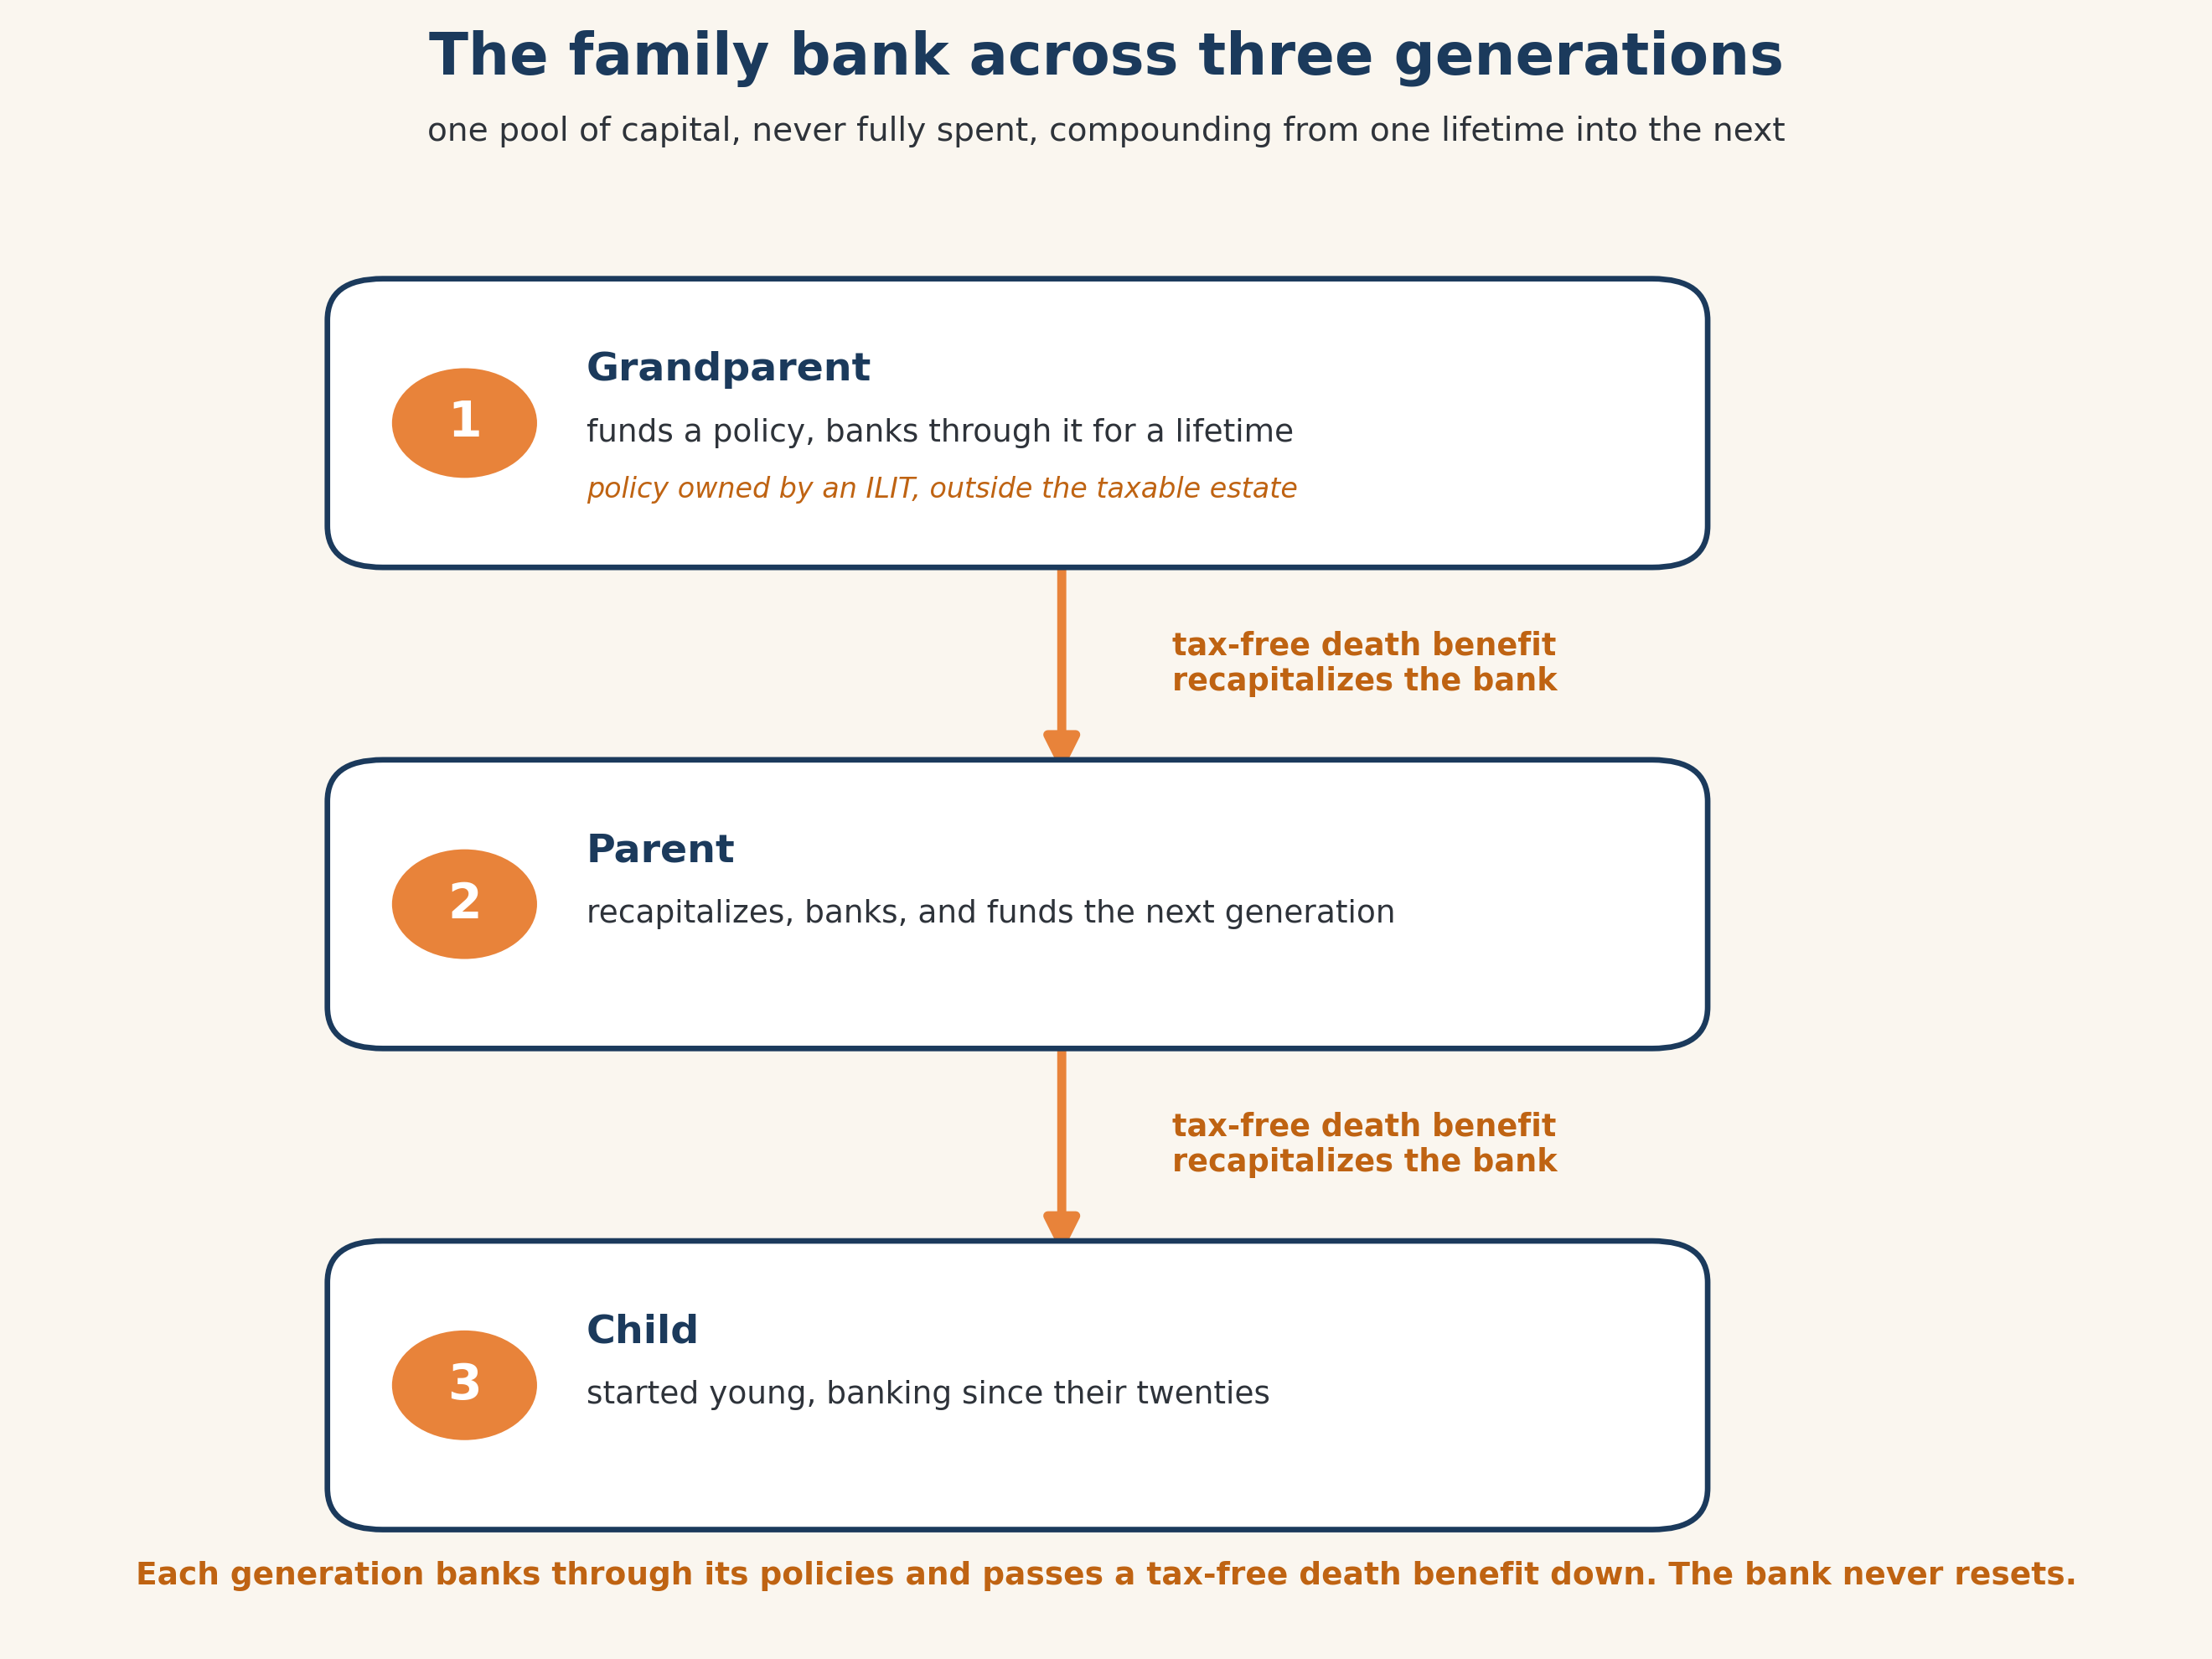
Figure: The tax-free death benefit recapitalizes the bank for the next generation, which never has to start from zero.
Start a policy on a child or grandchild and you hand them something most people spend a lifetime trying to build, a funded asset with decades of runway. By the time that 18-year-old reaches retirement age, the cash value on the current scale is over $3 million. Then the death benefit transfers, tax-free, and recapitalizes the family bank for the next generation, who get to start where the last one finished instead of from zero. This is not a trick reserved for the Rockefellers. It’s a structure any family can build, one well-designed policy at a time. If you move policies into an irrevocable trust to keep the death benefit out of the government’s reach, move the ones you’re not actively banking through, and talk to an estate attorney first.

Part VII: Getting Started
Chapters 15 through 16
Answer the doubts, and take the first steps.

Chapter 15 — Objections, Myths, and Misconceptions
Study guide, with one worked comparison.
The big idea. Most objections to cash value life insurance contain a fair kernel, and then a wrong conclusion. The book takes them one at a time. The one to run with real numbers is the big one: just buy term and invest the difference. So let’s run it for real, same 40-year-old man, same 20 years.
 | Buy term + invest the difference | Whole life
Paid or invested per year | $24,210 | $24,810
Value at year 20, before tax | $992,501 | $839,760
After tax on gains | $916,256 | $839,760
Death benefit in force | $500,000, then it expires | $1.8M+ and rising, for life
Discipline required | invest every year, never sell low | built in

Read that fairly. On raw dollars, the term-and-invest path can come out ahead, $916,256 against $839,760, if three things all happen: you invest the difference every single year, you actually earn the 7 percent, and you never panic and sell low. That’s the fair kernel. Here’s the wrong conclusion. Investing is hard, the emotions are real, and most people don’t stay the course for 20 years. Whole life delivers through discipline, guarantees, tax treatment, and a death benefit that never expires, while the term policy is gone at year 20 right when it gets expensive to replace. The real answer is rarely term or whole life. It’s term and a properly designed cash value policy.
Questions to consider.
- Be honest about your own track record: have you actually invested every spare dollar, every year, through every downturn?
- Which matters more to you, the highest possible number on a spreadsheet, or a structure that works even when you don’t feel like being disciplined?

Chapter 16 — Your First 90 Days
Study guide and worksheet.
The big idea. Knowing all of this changes nothing until you start. The book lays out 90 days in three phases. Here is the checklist version, so you can work it.
Phase One, Days 1 to 30: get your cash flow right.
- List every balance and its rate. Add up the idle cash in your accounts.
- Price a line of credit, HELOC or personal. You’re not committing, you’re pricing the tool.
- Find the money. Look at recurring expenses and capital you’re already spending, that’s where the funding comes from.
Phase Two, Days 31 to 60: design and apply.
- Decide whole life, IUL, or both, based on your timeline and what you want the money to do.
- Vet an agent. Get multiple illustrations. If one says you’re “the exception,” get a second and third opinion, they don’t tell everyone that for no reason.
- Apply, and don’t fear the exam. It’s just underwriting.
Phase Three, Days 61 to 90: fund it and start banking.
- Fund the policy the way the illustration assumes, promptly, so it performs the way it’s drawn.
- Set up the line against the cash value.
- Run your first cycle. A real one. Borrow for something you were going to buy anyway, and pay yourself back on schedule.
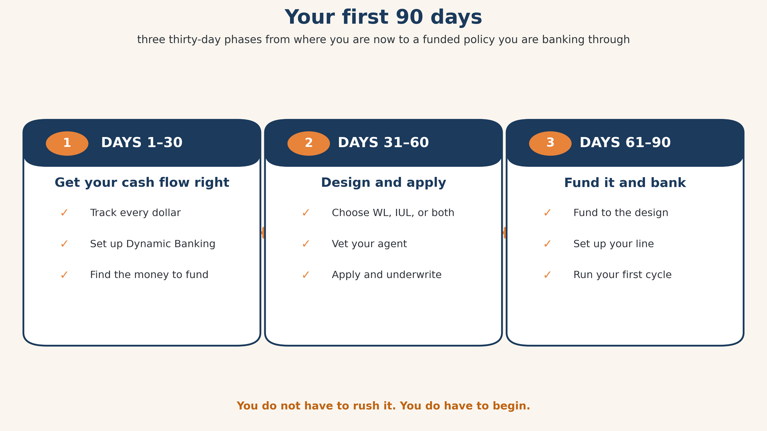
Figure: Three phases. You don’t have to rush it. A slower pace that matches what you have available is fine. The important thing is to start.
If you don’t own a home, you’re not left out. A disciplined credit card used as a float, or a personal line of credit, gets you running the cash flow habit now, and the policy’s own line takes over later. Start where you are.
The system doesn’t hand you a bank. It grows one. The sooner you start, the more time does the work for you. If you want help, reach out. We offer free consults to anyone, and it’s not a sales ploy. We’re here to help.

